“Intelligent Solar-Battery Energy Management System”
CSC-225 - Software Engineering
Project Proposal
V 1.0

By
# | Name | Roll No | Email
1 | Muhammad Uzair Sajid | 42 | bscs25f42@namal.edu.pk
2 | Muhammad Awais | 32 | bscs25f32@namal.edu.pk
3 | Iqra Bibi | 21 | bscs25f21@namal.edu.pk
4 | Tayyaba Akhtar | 59 | bscs25f59@namal.edu.pk



Department of Computer Sciences
Namal University
Mianwali, Pakistan
Submission Date: 9th October, 2026
Github Repository: https://github.com/muzairsajid102/Intelligent-Solar-Battery-Energy-Management-System
REVISION HISTORY
Date | Version | Description | Approved by
09-10-2026 | V 1.0 | Initially, all the features were defined but after meeting with the requirement provider, some new features such as Intelligent switching logic were defined. | Mam Asiya Batool

TABLE OF CONTENTS
# | Heading | Pg No
1. | Introduction | 5
2. | Problem Statement | 5
3. | Project Objectives | 6
4. | Project Scope | 6
5 | Stakeholders Identifications | 7
6. | Software Development Methodology | 7
7. | Tools and Techniques | 9
8. | References | 11

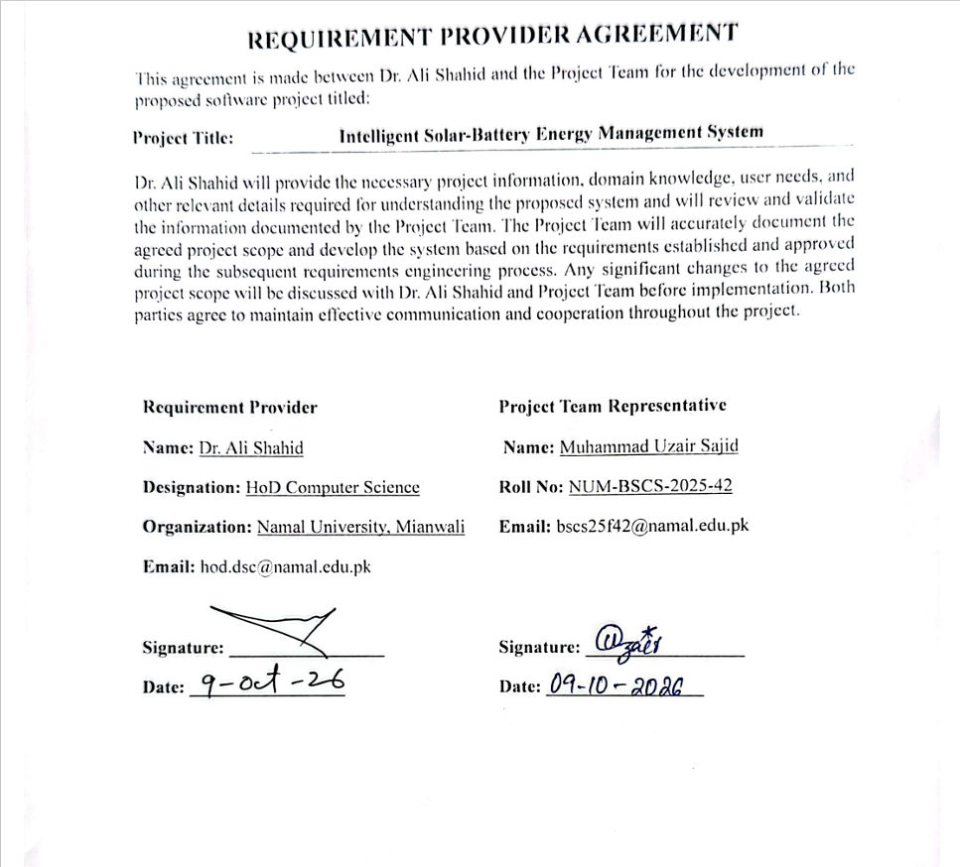

INTRODUCTION:
In Pakistan, many homes now install hybrid solar systems that combine solar panels, batteries, and the WAPDA grid to deal with high electricity bills and regular load shedding. During the day, solar panels produce power, excess energy charges the battery, and WAPDA is used whenever there is a shortage.
Even though these three sources are present, most households rely on manual switches or fixed inverter settings to handle them. Fixed settings do not change when household load goes up, when the weather turns cloudy, or when load shedding is about to happen. Because of this, batteries often run out right before an evening power cut, or expensive WAPDA power gets used even when battery power is sitting idle.
This project develops a web prototype called the “Intelligent Solar-Battery Energy Management System.” It does not need real solar panels or physical inverter wiring, instead, it uses simulated energy data to test smarter switching decisions. The web application will show simulated readings on a dashboard, calculate how much battery charge to keep for scheduled load shedding, estimate bill costs under different tariffs, and clearly explain why a particular energy source is recommended.

PROBLEM STATEMENT:
Managing solar, battery, and WAPDA power at the same time is difficult for homeowners when they only have static settings or manual switches. This creates three main problems:
- Wasted energy and money: Systems often draw power from WAPDA during ordinary hours while the battery is full, or they discharge the battery during sunny hours instead of running appliances directly on solar.
- Empty batteries during load shedding: Inverters do not know when the next power cut will take place. They keep running until the battery is too low, leaving the home without backup when WAPDA goes off.
- No cost visibility or explanations: Homeowners cannot easily tell how much money their current setup is saving under their electricity tariff, and existing inverters do not explain why they switch between sources.
Homeowners and solar installers need a simple software tool to simulate better switching rules, protect backup power for scheduled blackouts, and compare electricity costs before changing physical setups.

PROJECT OBJECTIVES:
- Web Based Prototype to demonstrate the concept of Energy management between Solar, Battery and WAPDA.
- Display status of Solar production, Battery level, Household load and WAPDA on web interface.
- Intelligent Decision-Making System to suggest which energy source should be used on the basis of available energy conditions.
- Saving Battery Source for the nighttime and not discharge unnecessarily during daytime.
- Display Recommendations on Web Dashboard along with energy usage status so that the user can get all information in a single place.
- Historical Energy data and Basic Analytics Display so that the user could understand the energy consumption and system performance.
- Demonstrate the complete working concept of intelligent energy management through a web prototype without developing a physical hardware system.
- Comparing against a fixed baseline to test the proposed system against standard fixed-threshold switching under the exact same simulated conditions to measure WAPDA savings and backup reliability.
- Calculate electricity costs using configurable peak, off-peak, and net metering rates to estimate electricity costs under different switching choices.

- PROJECT SCOPE:
This project will include:
- Web dashboard showing simulated solar, battery, household load, and WAPDA values.
- Decision logic to recommend the best power source.
- Baseline fixed threshold switching mode for performance comparison.
- Battery reserve calculations based on entered load-shedding hours.
- Electricity bill estimation based on user-entered tariffs.
- Text explanations showing why a source was picked.
- Graphs showing historical generation, usage, and battery levels.
- Settings page for entering outage times, reserve limits, and manual overrides.

This project will not include:
- Real solar panels, physical batteries, or physical inverters.
- Hardware wiring, relays, or direct inverter controls.
- Commercial deployment in an actual building or distribution grid.

- STAKEHOLDER IDENTIFICATION:

Table 1: Stakeholders and their role in system
Stakeholder | Role | Interaction with System
Homeowners | Primary Users with electricity connections. | Monitor solar production, battery level, household load, and WAPDA status. View alerts, energy information, and control the system when required.
Solar Installers / EPC Companies | Install and maintain solar-battery systems for users. | Monitor installed systems, view system information, and assist with system configuration and management.
System Administrator | Manages users and overall system configuration. | Manage user accounts, system settings, configurations, and access to the system.
Development Team | Develops, tests, and maintains the software system. | Develop, test, update, and maintain the system according to the project requirements.
- SOFTWARE DEVELOPMENT METHODOLOGY:
  - Selected Methodology
The team plans to follow an Agile methodology for Intelligent Solar-Battery Energy Management System. The Agile is suitable for this project because the software will be developed in stages, and team can review each part before moving forward. Feedback from the requirement provider can be considered throughout development. This will help the team to improve the web prototype gradually and make changes when the requirements become clear.

  - Development Process
The work will be divided into smaller stages. First the team will gather the requirements, including the information that should appear on dashboard and the rules used to recommend an energy source. Next the team will make the system design and web interface prototype. After the design is reviewed, the team will implement the dashboard, energy source decision logic, simulated energy data, alerts and basic historical analytics. The team will then test the features, resolve the issues and demonstrate the working prototype. Since the project does not include physical hardware integration, energy readings will be simulated for development purpose.

  - Team Coordination, Feedback and Change Management
Team members will divide the work according to the main project tasks and keep track of their progress through a shared project board. GitHub will be used to demonstrate the code changes and collaborate on project files. The team will arrange regular discussions and meetings with the requirement provider and supervisor to review the progress and collect feedback. When a change is suggested, the team will discuss its importance, update the task list, and make the change if it fits the project scope and available time.

  - Tentative Schedule
The following schedule is tentative. The team may adjust according to feedback, project progress and academic deadlines.
Table 2: Tentative development schedule
Activity | Months | Expected Outcome
Requirements gathering and analysis | 1-2 | Agreed requirements and project plan
System design and UI/UX prototype | 2-3 | System diagrams and approved interface design
Frontend development | 3-5 | Working web dashboard and navigation
Backend and database development | 5-7 | Data handling and backend services
Energy decision logic and simulation | 7-8 | Simulation source-selection recommendations
Alerts, analysis and historical data | 8-9 | Dashboard alerts and basic energy reports
Integration and testing | 9-10 | Integrated prototype with issues corrected
Feedback, improvements and final validation | 10-11 | Updated prototype based on review
Documentation and final demonstration | 11-12 | Final report and project demonstration

  - Tentative Gantt Chart

Table 3: Tentative Gantt Chart
Activity/Month | 1 | 2 | 3 | 4 | 5 | 6 | 7 | 8 | 9 | 10 | 11 | 12

Requirements Gathering

System design and UI/UX prototype

Frontend Development

Backend and database development

Decision logic and simulation

Alerts, analysis and historical data

Integration and testing

Improvements and final validation

Documentation & deployment

Monthly RP Meeting

- TOOLS AND TECHNOLOGIES:

Table 4: Proposed Tools and Technologies
# | Category | Tools and Technologies | Purpose
1 | UI/UX Design | Figma & draw.io | Design the user interface and interactive web prototype before implementation.
2 | Frontend | React.js (with Vite) | Component-based interactive dashboard and user interface
3 | UI Styling | Tailwind CSS | A utility-first CSS framework used to build responsive, consistent dashboard grid cards, alerts, and navigation layouts.
4 | Data Visualization | Recharts | Charts of energy generation, consumption and source usage in real time and historical.
5 | Backend | Python (FastAPI) | High-performance asynchronous backend framework that connects the web interface with the simulation logic, handles REST endpoints, and manages data flow.
6 | Data Simulation | NumPy & Pandas | Used to model synthetic solar generation curves, process time-series household load profiles (e.g., benchmark public datasets), and calculate battery SOC state transitions.
7 | Predictive Logic | scikit-learn | Implements baseline forecasting models (such as Linear Regression or Random Forest Regressors) to estimate short-term energy demand and solar generation.
8 | Database | PostgreSQL (with SQLAlchemy ORM) | Recording energy readings, source information, alerts and historical data.
9 | Testing and Verification | Pytest and Postman | Pytest executes automated unit tests on core decision and battery-reserve algorithms. Postman is used to test, validate, and document backend REST API endpoints and data payloads.
10 | Version Control | Git and GitHub (branches, pull requests, Issues) | Version control, collaboration, and maintaining project materials.
11 | Development Environment | Visual Studio Code, Node.js (LTS), npm | Writing, editing and executing the frontend and backend toolchains.

REFERENCES
[1] L. L. Motta, W. S. Alvarez, H. R. Carvajal, F. B. Neto, E. R. de Lima, and L. G. P. Meloni, “A cloud architecture for home energy management systems: A conceptual model,” Energy Informatics, vol. 8, Art. no. 142, 2025, doi: 10.1186/s42162-025-00599-1
[2] Tesla, “Tesla App for Energy,” Tesla Support. [Online]. Available: https://www.tesla.com/support/energy/powerwall/mobile-app/tesla-app-for-energy. [Accessed: Oct. 8, 2026].
[3] SolarEdge Technologies, “SolarEdge ONE,” SolarEdge. [Online]. Available: https://www.solaredge.com/en/solaredge-one. [Accessed: Oct. 8, 2026].
[4] Solarlink App, [Online]. [Accessed: Oct. 9, 2026].
[5] Agile Alliance, “What Is Agile? Agile 101.” [Online]. Available: https://agilealliance.org/agile101/. [Accessed: Oct. 9, 2026].

AI Prompts Used
# | Prompt | AI Used
1 | I want you to give me the names of some apps and websites being used in Pakistan for Solar controlling that I can visit to gain some knowledge. | Chatgpt
2 | Give me the link of any article where I can find that these are the stakeholders for this system. | Chatgpt
3 | Give me the list of tools and techniques that are needed for developing this software. | Chatgpt
4 | Review the proposed Intelligent Solar-Battery Energy Management System and help me draft a suitable Software Development Methodology section for a web-based prototype. Explain the selected methodology, development phases, team coordination, feedback and change management, and a tentative one-year development schedule. Keep the language clear and appropriate for an undergraduate Software Engineering project | Chatgpt
5 | This is my project proposal, align it with CCP Milestone 1 pdf and tell if the proposal is complete or not, suggest changes needed, if any. | Gemini

